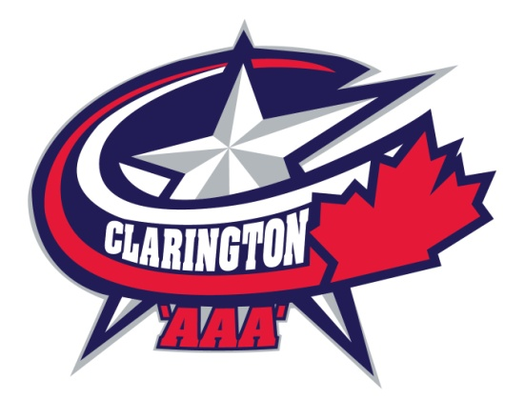

COACHING APPLICATION PACKAGE
FOR THE CLARINGTON ZONE HOCKEY ASSOCIATION

PLEASE RETURN THE COMPLETED FORM BY, November 17th, 2021 TO:

E-Mail: Rick@grantagg.com

Forms and attachments to be submitted in PDF format

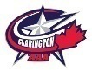CLARINGTON ZONE HOCKEY ASSOCIATON
HEAD COACH APPLICATION 2022/2023 SEASON
Name: ___________________________________________________________
Address:
Phone:
E-mail:

NCCP CERTIFICATION NUMBER (IF APPLICABLE) ________________________
OMHA CERTIFICATION : LEVEL________ EXPIRY DATE __________________

TEAM APPLYING (i.e. TEAM / YEAR)
- FIRST CHOICE:
- SECOND CHOICE:

Would you have a family member on the team? Yes _____ No ____
IF yes, THEN please give date of birth: (DDMMMYYYY):
IF you were unsuccessful for Head Coach position would you like to be considered for an Assistant Coach? Yes _____ No _____
Coaching Experience: (Please complete the following)

YEAR | LEVEL | POSITION | ASSOCIATION

RESUME ATTACHED: Yes ____ NO ____

All required documentation attached: Yes ____ NO ____

Selected applicant must agree and adhere to the Rostered Bench Staff Certification Requirements Policy.
Coach Selection Process for Open Positions

- All candidates must submit a completed Clarington Zone Hockey Association (CZHA) coaching application.
- All candidates must meet the minimum requirements as set out by the CZHA.
- All candidates must provide a one or two page “basic outline” of their season plan.
- Coaches applying to return to the same team should also provide a document on how their team has progressed in the current season versus their plan.
- All candidates must provide a list of any people they are considering for their staff.
- All candidates must provide a full team contact list from the previous season coached.

Not including one of these requirements may lead to the removal of the candidate’s application from the process. Applicants are encouraged to include a cover letter including any further information that may aid the CZHA in the selection process. Prior coaching or mentoring experience as well as any Coaching courses taken should be noted.

Coaches who are successful in being awarded a team will be required to submit a formal annual plan to the CZHA Director of Coach and Player Development and will be asked to report progress versus this plan through the course of the season. This is done to ensure a minimum standard of instruction is met in order to prepare each team for progression into older age groups. Failure to produce this plan prior to the start of the season could result in the removal of that coach from their position.

While the CZHA appreciates all applications, only those applicants being considered for an interview will be contacted. All other applicants will receive an acknowledgement thanking them for expressing an interest in coaching in the CZHA.

Coaches are to understand that the CZHA Governing Committee must approve all coaching staff prior to them being named to the roster. A team’s roster will not be completed until the staff has been approved. Coaches are advised that they are not to announce any coaching staff members until the CZHA Governing Committee has approved them.

Coaches may be asked to consider taking on their staff as an assistant a candidate chosen by the CZHA Governing Committee from applicants for head coach.

All coaches and staff are required to sign a Code of Conduct form and Criminal Offence Declaration form. Refusal to sign will lead to removal from the team.

By signing this application, potential candidates agree that they have read and understand and will follow the outlined requirements.

I certify that the above information represents a true and accurate detail of my qualifications. I hereby grant permission for authorized agents of the Clarington Zone Hockey Association to contact the above references with regard to all like and similar matters that may pertain to my “ability to” and “manner in which to” perform all duties and obligations to which I submit this my application.

APPLICANT (Print name)

APPLICANT (Signature)

DATE

COACHING APPLICATION 2022/2023 SEASON Cont’d

MINIMUM CREDENTIAL REQUIREMENTS CZHA HEAD COACHES:
Coaching applicants must meet the following minimum credentials to be accepted as a potential candidate. These minimums are specified to ensure that coaches selected will have a clear understanding of what is involved in operating a AAA level hockey program. While these minimum requirements are specified, the coach selection committee reserves the right to waive these requirements if there is no other suitable qualified applicant.

NOVICE AAA (8 YEAR OLDS) NOT Applicable No Team
DEVELOPMENT STREAM 1 certification as accepted by the OMHA or applicant must provide proof of being registered in and completing the DEVELOPMENT STREAM 1 Clinic before September 1st of the season applied to coach in
AND
- 1 year as a head coach of a Rep level (AAA, AA, A) team or
- 2 years as an assistant coach of a Rep level (AAA, AA, A) team or
- 2 years as head coach of a select or house level team
MINOR ATOM TO PEEWEE AAA (9 to 12 YEAR OLDS) U10 to U12
DEVELOPMENT STREAM 1 certification as accepted by the OMHA or applicant must provide proof of being registered in and completing the DEVELOPMENT STREAM 1 Clinic before September 1st of the season applied to coach in
AND
- 1 year as a head coach of a Rep level (AAA, AA, A) team or
- 2 years as an assistant coach of a Rep level (AAA, AA, A) team or
- 3 years as head coach of a select or house level team

Note: A coach applying for Peewee AAA as their first year with the age group must be willing to participate in the HP1 Development course prior to the Peewee year so that they may be considered for more than one season with the team.

MINOR BANTAM to MIDGET AAA (13, 14, 15, 16 & 17 YEAR OLDS) U13 to U18

HIGH PERFORMANCE 1 certification as accepted by the OMHA or applicant must provide proof of being registered in and completing the HIGH PERFORMANCE 1 Clinic before September 1st of the season applied to coach in
AND
- 2 years as a head coach or assistant coach of a AAA, Junior or University or College team

